Day 5 Class Exercise

TASK 1:

**package** com.selenium.project1.selenium1;

**import** org.openqa.selenium.By;

**import** org.openqa.selenium.WebDriver;

**import** org.openqa.selenium.WebElement;

**import** org.openqa.selenium.chrome.ChromeDriver;

**import** org.openqa.selenium.chrome.ChromeOptions;

**import** org.openqa.selenium.interactions.Actions;

**import** io.github.bonigarcia.wdm.WebDriverManager;

**public** **class** Day5 {

**public** **static** **void** main(String[] args) {

// **TODO** Auto-generated method stub

WebDriverManager.*chromedriver*().setup();

WebDriver driver;

ChromeOptions co = **new** ChromeOptions();

co.addArguments("--remote-allow-origins=*");

driver=**new** ChromeDriver(co);

driver.get("https://demoqa.com/droppable/");

//creating Elements for drag and drop

// WebElement drag=driver.findElement(By.id("draggable"));

// WebElement drop=driver.findElement(By.id("droppable"));

WebElement drag=driver.findElement(By.*id*("draggable"));

WebElement drop=driver.findElement(By.*id*("droppable"));

Actions act=**new** Actions(driver);

act.dragAndDrop(drag, drop).build().perform();

//doing actions

// Actions act=new Actions(driver);

// act.dragAndDrop(drag, drop).build().perform();

}

}

OUTPUT:

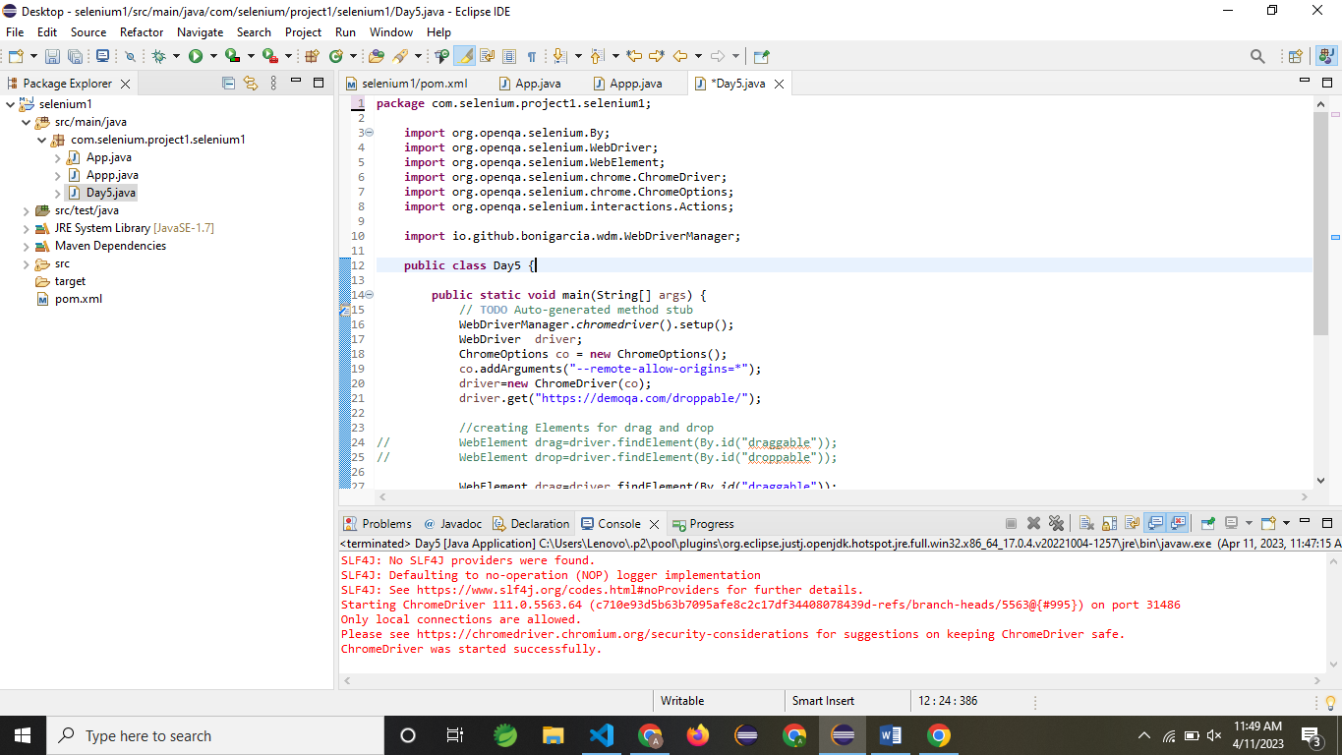

TASK 2:

**package** com.selenium.project1.selenium1;

**import** org.openqa.selenium.By;

**import** org.openqa.selenium.WebDriver;

**import** org.openqa.selenium.WebElement;

**import** org.openqa.selenium.chrome.ChromeDriver;

**import** org.openqa.selenium.chrome.ChromeOptions;

**import** org.openqa.selenium.interactions.Actions;

**import** io.github.bonigarcia.wdm.WebDriverManager;

**public** **class** Day5 {

**public** **static** **void** main(String[] args) {

// **TODO** Auto-generated method stub

WebDriverManager.*chromedriver*().setup();

WebDriver driver;

ChromeOptions co = **new** ChromeOptions();

co.addArguments("--remote-allow-origins=*");

driver=**new** ChromeDriver(co);

driver.get("https://jqueryui.com/droppable/");

driver.switchTo().frame(0);

WebElement drag1=driver.findElement(By.*id*("draggable"));

Actions act=**new** Actions(driver);

WebElement drop1=driver.findElement(By.*id*("droppable"));

act.dragAndDrop(drag1, drop1).build().perform();

}

}

OUTPUT:

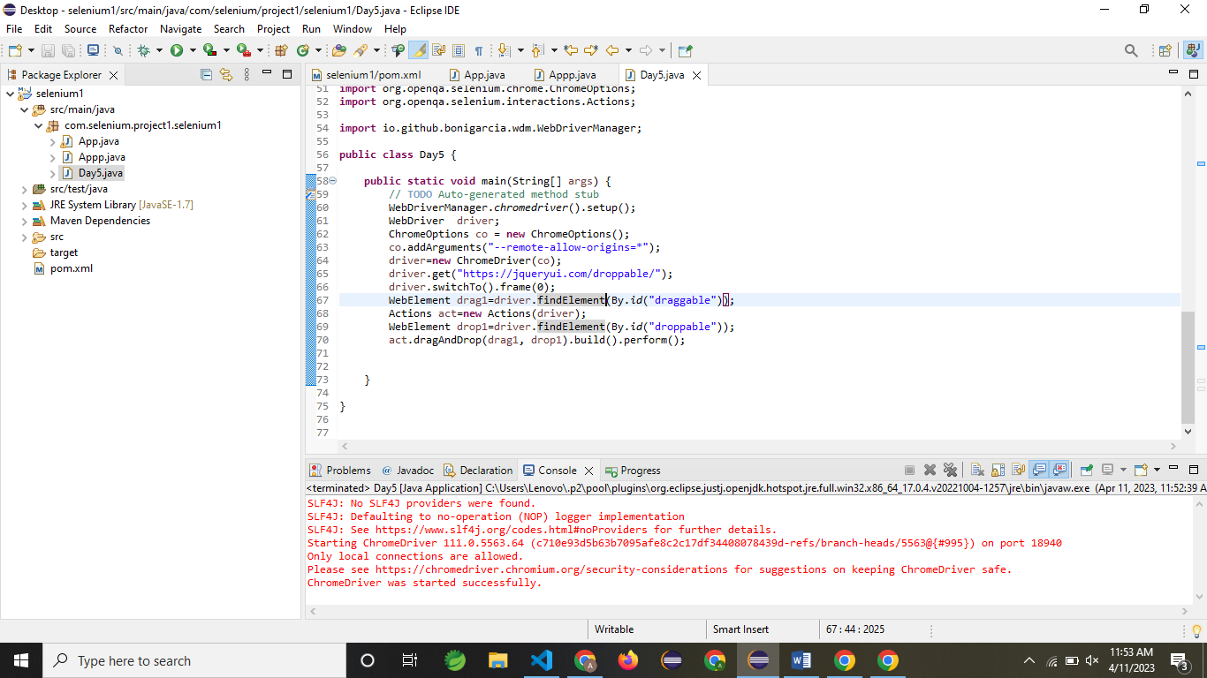

TASK 3:

**package** com.selenium.project1.selenium1;

**import** org.openqa.selenium.Alert;

**import** org.openqa.selenium.By;

**import** org.openqa.selenium.WebDriver;

**import** org.openqa.selenium.WebElement;

**import** org.openqa.selenium.chrome.ChromeDriver;

**import** org.openqa.selenium.chrome.ChromeOptions;

**import** io.github.bonigarcia.wdm.WebDriverManager;

**public** **class** DDay5 {

**public** **static** **void** main(String[] args) **throws** Exception {

// **TODO** Auto-generated method stub

WebDriverManager.*chromedriver*().setup();

WebDriver driver;

ChromeOptions co = **new** ChromeOptions();

co.addArguments("--remote-allow-origins=*");

driver=**new** ChromeDriver(co);

driver.get("https://demo.guru99.com/test/delete_customer.php");

driver.manage().window().maximize();

//enter 401 and clicking

WebElement txt1=driver.findElement(By.*name*("cusid"));

txt1.sendKeys("401");

driver.findElement(By.*name*("submit")).click();

//handling alert boxes

Alert alt=driver.switchTo().alert();

Thread.*sleep*(4000);

alt.dismiss();

txt1.clear();

txt1.sendKeys("402");

driver.findElement(By.*name*("submit")).click();

alt.accept();

Alert alt2=driver.switchTo().alert();

String txt=alt2.getText();

alt2.accept();

System.***out***.println(txt);

}

}

OUTPUT:

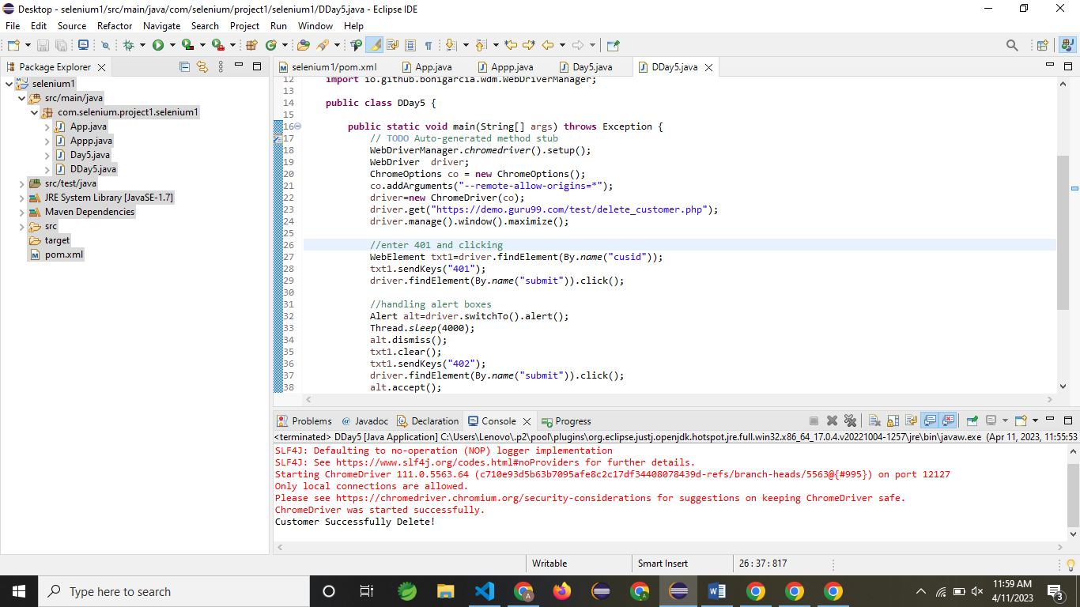

TASK 4:

/*package com.selenium.project1.selenium1;

import org.openqa.selenium.Alert;

import org.openqa.selenium.By;

import org.openqa.selenium.WebDriver;

import org.openqa.selenium.WebElement;

import org.openqa.selenium.chrome.ChromeDriver;

import org.openqa.selenium.chrome.ChromeOptions;

import io.github.bonigarcia.wdm.WebDriverManager;

public class DDay5 {

public static void main(String[] args) throws Exception {

// TODO Auto-generated method stub

WebDriverManager.chromedriver().setup();

WebDriver driver;

ChromeOptions co = new ChromeOptions();

co.addArguments("--remote-allow-origins=*");

driver=new ChromeDriver(co);

driver.get("https://demo.guru99.com/test/delete_customer.php");

driver.manage().window().maximize();

//enter 401 and clicking

WebElement txt1=driver.findElement(By.name("cusid"));

txt1.sendKeys("401");

driver.findElement(By.name("submit")).click();

//handling alert boxes

Alert alt=driver.switchTo().alert();

Thread.sleep(4000);

alt.dismiss();

txt1.clear();

txt1.sendKeys("402");

driver.findElement(By.name("submit")).click();

alt.accept();

Alert alt2=driver.switchTo().alert();

String txt=alt2.getText();

alt2.accept();

System.out.println(txt);

}

}

*/

package com.selenium.project1.selenium1;

import org.openqa.selenium.By;

import org.openqa.selenium.JavascriptExecutor;

import org.openqa.selenium.WebDriver;

import org.openqa.selenium.WebElement;

import org.openqa.selenium.chrome.ChromeDriver;

import org.openqa.selenium.chrome.ChromeOptions;

import io.github.bonigarcia.wdm.WebDriverManager;

public class DDay5 {

public static void main(String[] args) {

WebDriverManager.chromedriver().setup();

WebDriver driver;

ChromeOptions co = new ChromeOptions();

co.addArguments("--remote-allow-origins=*");

driver=new ChromeDriver(co);

driver.manage().window().maximize();

driver.get("https://www.abhibus.com/bus-ticket-booking");

//selecting and entering source

WebElement d=driver.findElement(By.xpath("//*[@id=\"source\"]"));

d.sendKeys("Coimbatore");

//selecting and entering destination

driver.findElement(By.xpath("//*[@id=\"destination\"]")).sendKeys("Chennai");

//Datepicker

WebElement dp=driver.findElement(By.xpath("//*[@id=\"datepicker1\"]"));

JavascriptExecutor js=(JavascriptExecutor) driver;

js.executeScript("arguments[0].setAttribute('value', '04/10/2023')", dp);

}

}

OUTPUT:

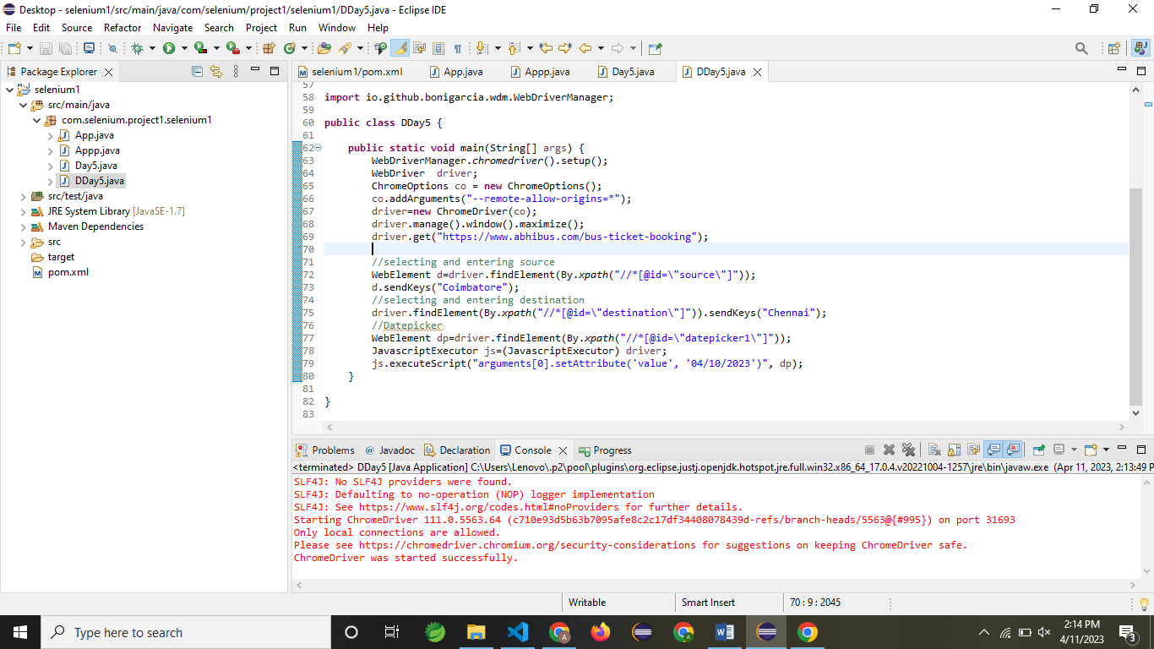

TASK 5:

**package** com.selenium.project1.selenium1;

**import** java.util.Iterator;

**import** java.util.Set;

**import** org.openqa.selenium.By;

**import** org.openqa.selenium.Keys;

**import** org.openqa.selenium.WebDriver;

**import** org.openqa.selenium.WindowType;

**import** org.openqa.selenium.chrome.ChromeDriver;

**import** org.openqa.selenium.chrome.ChromeOptions;

**import** io.github.bonigarcia.wdm.WebDriverManager;

**public** **class** DDAAY5 {

**public** **static** **void** main(String[] args) {

// **TODO** Auto-generated method stub

//chrome

WebDriverManager.*chromedriver*().setup();

ChromeOptions co=**new** ChromeOptions();

co.addArguments("--remote-allow-origins=*");

WebDriver driver=**new** ChromeDriver(co);

driver.get("https://google.com");

driver.manage().window().maximize();

driver.findElement(By.*name*("q")).sendKeys("Apple");

driver.findElement(By.*name*("q")).sendKeys(Keys.***ENTER***);

String parent=driver.getWindowHandle();

System.***out***.println(parent);

System.***out***.println(driver.getTitle());

driver.switchTo().newWindow(WindowType.***TAB***);

driver.get("https://google.com");

driver.manage().window().maximize();

driver.findElement(By.*name*("q")).sendKeys("Selenium");

driver.findElement(By.*name*("q")).sendKeys(Keys.***ENTER***);

driver.switchTo().newWindow(WindowType.***TAB***);

driver.get("https://google.com");

driver.manage().window().maximize();

driver.findElement(By.*name*("q")).sendKeys("Cucumber");

driver.findElement(By.*name*("q")).sendKeys(Keys.***ENTER***);

Set<String>s=driver.getWindowHandles();

Iterator<String> I1=s.iterator();

**while**(I1.hasNext())

{

String child=I1.next();

**if**(!parent.equals(child))

{driver.switchTo().window(child);

System.***out***.println(driver.switchTo().window(child).getWindowHandle());

System.***out***.println(driver.switchTo().window(child).getTitle());

}

}

}

}

OUTPUT:

